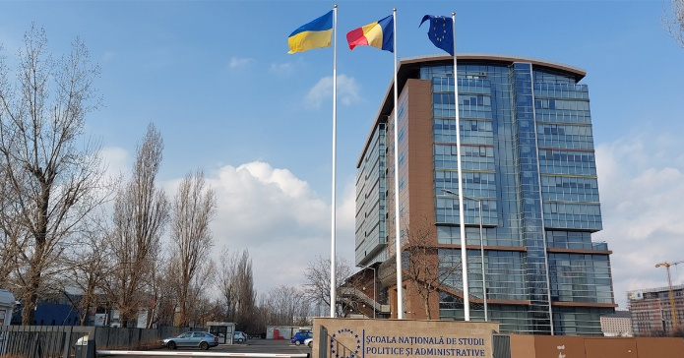 

**Erasmus + Blended Intensive Programme BIP**

# Digital Transformation in Public Services Bucharest, Romania

# Scholarship available

**National University of Political Studies and Public Administration**

(*Școala Națională de Studii Politice și Administrative din București,* **SNSPA**)

**Bucharest, Romania**

**1st to 6th of December 2025 | on-line course starts on 27 October 2025**

# What is this programme about?

This Blended Intensive Programme (BIP) is designed for students who want to explore how digital technologies are transforming public services and governance in Europe and beyond. The course connects perspectives from Romania, Finland, Lithuania, Bulgaria, Portugal, and the United States, offering participants an international and comparative approach to today’s most pressing challenges in public administration.

# Why join?

By participating, you will:

* Gain **practical knowledge** of digital governance, readiness, and reform trends in public administration.
* Learn to critically assess the **opportunities and risks** of digital transformation, including issues such as organizational change, ethical dilemmas, AI in democracies, and inclusion of minorities.
* Work in **multicultural teams** on real-life case studies, mentored by international professors and experts.
* Develop essential **21st century skills**: critical thinking, teamwork, innovation, and problem-solving in complex contexts (VUCA/BANI environments).
* Experience an **on-site Hackathon in Bucharest**, where you will pitch your solutions to experts, stakeholders, and peers.

# How does it work?

The programme combines **online** and **onsite learning**:

* **Weeks 1–5 (online, October–November)**: Lectures, discussions, and mentorship sessions delivered via Webex. You will engage with leading scholars and practitioners, explore comparative reforms across Europe, and prepare your team project.
* **Week 6 (onsite, Bucharest, December 1–6)**: Study visits to public institutions and organizations, interactive workshops, and the final Hackathon where your team presents its innovative solution to a panel.

# Where will it take place?

* Online sessions are hosted by the partner universities on Webex.
* The onsite activities take place in **Bucharest, Romania**, at the National University of Political Studies and Public Administration (SNSPA) and at partner public institutions.

# Why does it matter?

Digital transformation is reshaping how governments deliver services, make decisions, and engage citizens. This BIP equips you not only with academic insights but also with **hands-on experiences** that will prepare you for careers in public administration, policy-making, or international organizations.

# Structure of the BIP

## Week 1 (27-31 October 2025): Introduction and Foundations of Digital PA

Online. Lectures (Webex meeting link: <https://snspa.webex.com/meet/sala.unu>)

*Topics Covered*: Introduction to the program and Erasmus+ objectives. Presentation of the program and learning goals. Digital Transformation in Public Services: An Overview of Digital Governance and Readiness. Organizational readiness for digital transformation: leadership, employee mindset and organizational change.

*Activities*: Online lectures, readings, and a webinar with an expert on digital transformation in the public sector. Case study, discussion.

## Week 2 (03-07 November 2025): Identifying Challenges in Public Services

Online. Lectures and Mentorship (Webex meeting link: <https://snspa.webex.com/meet/sala.unu>)

*Topics Covered*: Navigating Complexity in Public Administration: Mastering VUCA and BANI Challenges. AI and democracies (hate speech and news manipulation - current trends and impacts). Digitalization process and inequalities of minorities groups. Anticipating ethical, societal, environmental impacts of digital transformations.

*Activities*: Desk research assignments to identify and document specific digital transformation challenges within the focus areas under wicked problems theory. Online lecture and discussion on specific projects. Problem-solving tasks.

## Week 3 (10-14 November 2025): Case studies and Mentorship

Online. Case studies and Mentorship (Webex meeting link: <https://snspa.webex.com/meet/sala.unu>)

*Topics Covered*: Public administration reforms: Digital trends (an overview of strategies and methods to enhance public performance). Public Administration Reforms in Bulgaria, Portugal, Lithuania.

*Activities*: Online lecture and presentation of comparative cases of strategies. Students will be asked to further reflect on existent reform patterns by examining websites of different public organisations across Europe. Participants study some cases of successful and not that successful examples of digital transformations. Participants are divided into teams to analyse selected organizations as real-life case studies and elaborate on the challenge to be solved during the meeting in Lisbon. Desk research on identified challenge(s) and preparation of potential questions for stakeholders to be asked.

## Weeks 4 (17-21 November 2025): Case studies and Mentorship

Online. Case studies and Mentorship (Webex meeting link: <https://snspa.webex.com/meet/sala.unu>)

*Activities*: Mentorship by teams. Preparation of the team reply to the challenge. Desk research.

## Week 5 (24-28 November 2025): Mentorship and preparatory work for study visits

Online. Mentorship and preparatory work for study visits (Webex meeting link: <https://snspa.webex.com/meet/sala.unu>)

*Activities*: Mentorship by teams. Preparation of the final report. Desk research and preparation for the study visits.

## Week 6 (01-06 December 2025): Study Visit - Bucharest

Onsite in Bucharest: study visits and Hackathon. Post-evaluation feedback

*Topics Covered*: Digital transformations. Digital skills for Civil Servants. Technology driven leadership

Technology decision-making. Developing an entrepreneurial culture in public sector organisations. Innovation in the Public Sector VS. Private Sector.

*Activities*: Study visits - Physical visits to the studied organizations, interviews and discussions to collect information that is important to address the team challenge. Lecture and group discussion on the topics. Hackathon and pitches by the students’ groups. Feedback survey and presentation.

# Your Profile

The BIP on Digital Transformation in Public Services is targeted at bachelor’s students in their last year and master’s students. Students of Economics, Business, Management and Political Science fields of study who are enrolled in UNWE are welcome to apply.

# Application

To apply for the BIP on Digital Transformation in Public Services you should provide:

* A short letter (max. 300 words) explaining your motivation for applying to the BIP,
* Curriculum vitae (education, work experience, language skills, study/work abroad, other relevant skills and experiences),
* Academic records (transcript of records).

# Selection

Submitted applications are evaluated by the academics and staff working in the BIP. Candidates will be evaluated based on their motivation letter and CV. In order to ensure equal participation among students from the different partner universities, the selection committee will aim at choosing four to maximum five students from each partner university. Final decisions also consider a range of criteria for cohort composition, including but not limited to disciplinary balance, institutional diversity, and demographic diversity.

# Additional Details

In order to complete your application, you will have to fill in the application form (https://forms.office.com/e/ThZuMW5hz5) and upload your CV, academic records and motivation letter (in Word or PDF format), together with:

* Copy of international passport or European identity card – to be uploaded in PDF;
* Passport photo in JPG format.

Applications must be submitted by the 30 September 2025. All documents must be in English, except for the academic records.

Results will be communicated by the 5 October 2025.

For questions, please send an email to [kkolarov@unwe.bg](mailto:kkolarov@unwe.bg).

# Scholarship

All selected students will receive scholarships for participation in the BIP according Erasmus+ Programme regulations.